**Slide - 10**

**Sourcing Decisions in a Supply Chain**

**Supplier Selection**

**Example 1 - Supplier Selection**

– Lawn Man, a manufacturer of lawn mowers has historically purchased bearings from a local supplier who charges $1.00per bearing. The purchasing manager has identified another potential source willing to supply the bearings at $0.97 per bearing. The local supplier has an average lead time of 2weeks and has agreed to deliver the bearing in batches of2,000. Based on past on-time performance, the purchasing manager estimates that the lead time has a standard deviation of 1 week. The new source has an average lead time of 6weeks with a standard deviation of 4 weeks. The new source requires a minimum batch size of 8,000 bearings. Lawn Man has a holding cost of 25 percent. It currently uses a continuous review policy for managing inventory and aims fora cycle service level of 95 percent. Weekly demand has a mean of 1,000 and a standard deviation of 300 bearings .Which supplier should the purchasing manager go with (ignore ordering cost and focus on material cost and holding cost when making your decision)?

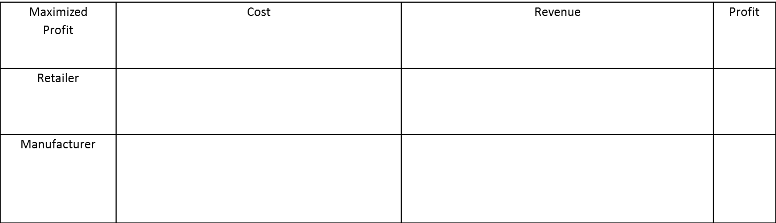

**Make to Order (no contract)**

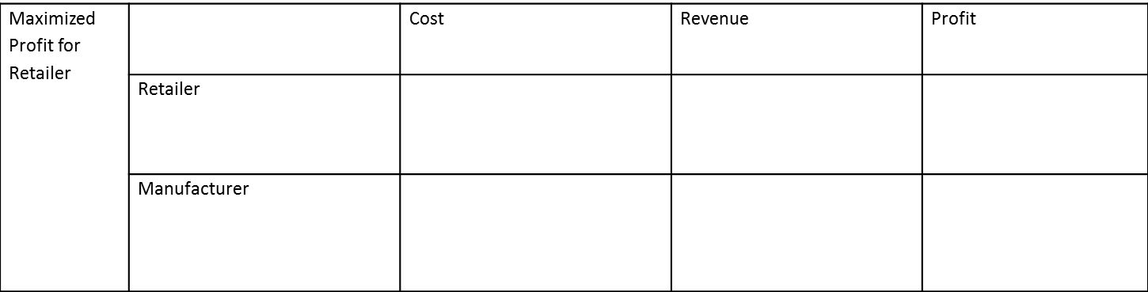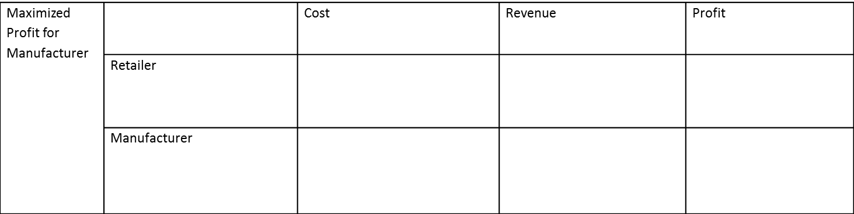

**Make to Order (buy-back contract)**



**Make to Order (revenue-sharing contract)**